DS PROJECT

TITLE OF THE PROJECT: Train Ticket Reservation.

TEAM MEMBERS: 22H51A66H5(P.Srinidh)

22H51A66E6 (D.Venky)

22H51A66G1(K.Aditi)

DESCRIPTION:

The project we have opted for this semester is Train ticket reservation. Train ticket reservation helps the passangers to book their tickets easily. It uses multiple data structures such as linked lists, queues and arrays to store and manage passenger, seat availability and fare details. We have used C language that allows users to book train tickets. It uses a structure to store passenger details and allows the user to enter the source and destination of their travel. The program then displays the available trains and their timings. The user can choose a train and the program will allocate seats. It also calculates the fare and displays the bill.

The train ticket reservation system is a convenient platform that allows users to easily book, cancel, and view train tickets. When a user selects the "Book Ticket" option, they are presented with a list of available train options to choose from. Once they have selected a train, they can then proceed to select their desired seat from the available options.

In case the user needs to cancel a ticket, they can select the "Cancel Ticket" option and provide the ticket number or booking reference. The system will then validate the input and, if the ticket is found, proceed to cancel the booking. The seat availability will be updated accordingly, and a confirmation message will be displayed to the user.

The train ticket reservation system operates in a loop, continuously presenting the main menu options until the user chooses to exit. This ensures a seamless and user-friendly experience for booking, canceling, and viewing train tickets.

ALGORITHM:

STEP 1- START

STEP 2- Declare the source and destination details of the passenger

STEP 3- Check whether train is available or not

STEP 4- if yes enter the details of passenger for booking ticket

4.1- if no refuse the entry of source and destination details

STEP 5- Again check the seats are available or not

5.1- if yes book the preferable seat

5.2- if no abort the ticket booking

OR

if no waiting list is coniform

STEP 6- Then check waiting list seat is confirmed or not

6.1- if yes display the seat number

6.2- if no ticket is not confirmed

STEP 7- then at last display train ticket

STEP 8- STOP

FLOW CHART:

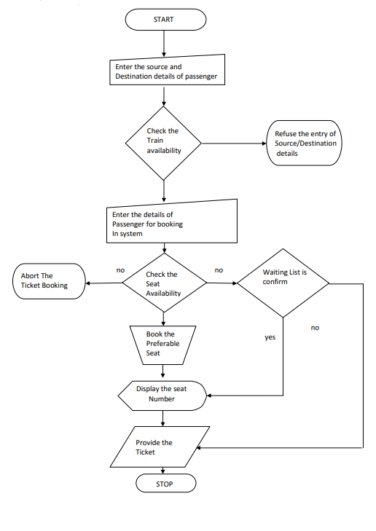

SOURCE CODE:

// C program for the above approach

#include <conio.h>

#include <stdio.h>

#include <stdlib.h>

#include <string.h>

// Defining Structure

**typedef** **struct** mynode {

**char** name[20];

**char** gen[6];

**int** age;

**struct** mynode* link;

} Node;

Node* start = NULL;

**void** details(**int**);

**int** seat(**int**);

**int** cal(**int**, **int**, **int**);

**void** bill(**int**, **int**);

// Global variables

**char** source[20], des[20], train[40];

**char** station[40], cla[40];

**int** time1, time2, a[55];

// Driver Code

**void** main()

{

**int** i, j, a1, a2, b, c, **int** x = 0, d, e, r;

**char** o;

**printf**("Enter Number Of Passengers: ");

**fflush**(stdin);

**scanf**("%d", &j);

    // Calling details() function with

    // argument number of passenger

    details(j);

**printf**("Enter The Source Place: ");

**fflush**(stdin);

**gets**(source);

**printf**("Enter The Destination Place: ");

**gets**(des);

**printf**("\t\tThe Following Trains "

           "Are Available.....\n");

**printf**("\t\t1. Rajdhani Express.."

           ".......10:00 "

           "a.m........Sealdah Station\n");

**printf**("\t\t2. Satabdi Express..."

           ".......05:00 "

           "p.m........Howrah Station\n");

**printf**("\t\t3. Humsafar Express..."

           ".......11:00 "

           "p.m........Kolkata Chitpur"

           " Station\n");

**printf**("\t\t4. Garib-Rath Express"

           ".........05:00 "

           "p.m........Sealdah Station\n");

**printf**("\t\t5. Duronto Express..."

           ".........07:00 "

           "a.m.........Santraganchi"

           "Station\n");

**scanf**("%d", &i);

**do** {

**switch** (i) {

**case** 1: {

**strcpy**(train,

                   "Rajdhani Express");

**strcpy**(station,

                   "Sealdah Station");

            time1 = 10;

            time2 = 00;

            a1 = 2099;

            a2 = 1560;

            // Calling cal() function

            // with the three argument

            // and return value

            d = cal(a1, a2, j);

**printf**("Total Bill Amount:"

                   " %d\n",

                   d);

        }; **break**;

**case** 2: {

**strcpy**(train,

                   "Satabdi Express");

**strcpy**(station,

                   "Howrah Station");

            time1 = 05;

            time2 = 00;

            a1 = 1801;

            a2 = 981;

            // Calling cal() function with

            // three argument & return value

            d = cal(a1, a2, j);

**printf**("Total Bill Amount:"

                   "%d\n",

                   d);

        }; **break**;

**case** 3: {

**strcpy**(train,

                   "Humsafar Express");

**strcpy**(station,

                   "Kolkata Chitpur Express");

            time1 = 11;

            time2 = 00;

            a1 = 2199;

            a2 = 1780;

            // Calling cal() function with

            // three argument & return value

            d = cal(a1, a2, j);

**printf**("Total Bill Amount: %d\n", d);

        }; **break**;

**case** 4: {

**strcpy**(train, "Garib-Rath Express");

**strcpy**(station, "Sealdah Station");

            time1 = 05;

            time2 = 00;

            a1 = 1759;

            a2 = 1200;

            // Calling cal() function with

            // three argument & return value

            d = cal(a1, a2, j);

**printf**("Total Bill Amount: %d\n", d);

        }; **break**;

**case** 5: {

**strcpy**(train, "Duronto Express");

**strcpy**(station, "Santraganchi Station");

            time1 = 07;

            time2 = 00;

            a1 = 2205;

            a2 = 1905;

            // Calling cal() function with

            // three argument & return value

            d = cal(a1, a2, j);

**printf**("Total Bill Amount: %d\n", d);

        }; **break**;

**default**:

**printf**("Enter Correct choice.....\n");

            x = 1;

**break**;

        }

    } **while** (x);

**printf**("Now Book Your Seats......\n");

    // Calling seat() function with number

    // of passenger

    seat(j);

    // Calling bill() function with

    // the number of passenger

    // and amount argument

    bill(d, j);

}

// Function for calculation of amount

**int** cal(**int** y1, **int** y2, **int** h)

{

**int** b, c, i, t, r, n;

**printf**("\t\tEnter Your Choice......\n");

**printf**("\t\t1. Sleeper Class....\n");

**printf**("\t\t2. A.C Class.......\n");

**scanf**("%d", &i);

**switch** (i) {

**case** 1: {

**strcpy**(cla, "Sleeper Class");

        b = y2 * h;

        c = b + (b * 0.18);

    } **break**;

**case** 2: {

**printf**("\t\tEnter Your Choice....\n");

**printf**("\t\t1. 3A Class....\n");

**printf**("\t\t2. 2A Class....\n");

**printf**("\t\t3. 1st Class A.C.....\n");

**scanf**("%d", &n);

**switch** (n) {

**case** 1: {

**strcpy**(cla, "3A Class");

            b = y1 * h;

            c = b + (b * 0.18);

        } **break**;

**case** 2: {

**strcpy**(cla, "2A Class");

            b = (y1 + 1000) * h;

            c = b + (b * 0.18);

        } **break**;

**case** 3: {

**strcpy**(cla, "1st Class A.C.");

            b = (y1 + 5000) * h;

            c = b + (b * 0.18);

        } **break**;

**default**: {

**printf**("\t\tEnter Right Choice......\n");

        }

        }

    } **break**;

**default**: {

**printf**("\t\tEnter Right Choice......\n");

    }

    }

**return** c;

}

// Function for taking details

// of passengers

**void** details(**int** k)

{

**int** i, a;

**char** val[20], gen[6];

**for** (i = 1; i <= k; i++) {

**printf**("Enter The %dth Passenger Name: ", i);

**fflush**(stdin);

**gets**(val);

**printf**("Enter The %dth Passenger Gender: ", i);

**fflush**(stdin);

**gets**(gen);

**printf**("Enter The %dth Passenger Age: ", i);

**fflush**(stdin);

**scanf**("%d", &a);

        // Calling add_node() function

        add_node(val, gen, a);

    }

}

// Function to add details in node

// for each passengers

**void** add_node(**char** lol[20], **char** der[6], **int** b)

{

    Node *newptr = NULL, *ptr;

    newptr = (Node*)**malloc**(**sizeof**(Node));

**strcpy**(newptr->name, lol);

**strcpy**(newptr->gen, der);

    newptr->age = b;

    newptr->link = NULL;

**if** (start == NULL)

        start = newptr;

**else** {

        ptr = start;

**while** (ptr->link != NULL)

            ptr = ptr->link;

        ptr->link = newptr;

    }

}

// Function for choosing seats

**int** seat(**int** p)

{

**int** i;

**printf**("\t           -:SEAT MATRIX:-        \n");

**printf**("\t(U)    (M)        (L)    (L)    "

           "    (U)\n\n");

**printf**("\t01    02        03\t04        "

           "05\n\n");

**printf**("\t06    07        08\t09        "

           "10\n");

**printf**("\t11    12        13\t14        "

           "15\n\n");

**printf**("\t16    17        18\t19        "

           "20\n");

**printf**("\t21    22        23\t24        "

           "25\n\n");

**printf**("\t26    27        28\t29        "

           "30\n");

**printf**("\t31    32        33\t34        "

           "35\n\n");

**printf**("\t36    37        38\t39        "

           "40\n");

**printf**("\t41    42        43\t44        "

           "45\n\n");

**printf**("\t46    47        48\t49        "

           "50\n");

**printf**("\t51    52        53\t54        "

           "55\n\n");

**printf**("\t56    57        58\t59        "

           "60\n");

**printf**("\tEnter Seat Numbers: \n");

**for** (i = 0; i < p; i++)

**scanf**("%d", &a[i]);

}

// Function for printing receipt

**void** bill(**int** y, **int** j)

{

**int** i;

    Node* ptr = start;

**for** (i = 1; i <= j; i++) {

**printf**("\t\t\%dst Passenger Name: ", i);

**puts**(ptr->name);

**printf**("\t\t%dst Passenger Gender: ", i);

**puts**(ptr->gen);

**printf**("\t\t%dst Passenger Age: %d\n\n", i,

               ptr->age);

        ptr = ptr->link;

    }

**printf**("\t\tSource Place: ");

**puts**(source);

**printf**("\t\tDestination Place: ");

**puts**(des);

**printf**("\t\tThe Boarding Station: ");

**puts**(station);

**printf**("\t\tTrain Is: ");

**puts**(train);

**printf**("\t\tAllocated Class: ");

**puts**(cla);

**printf**("\t\tBoarding Time: %d:%d\n", time1, time2);

**printf**("\t\tTotal Bill Amount: %d\n", y);

**printf**("\t\tAllocated Seats Are: \n");

**for** (i = 0; i < j; i++) {

**printf**("\t\t%d ", a[i]);

    }

**printf**("\n");

**printf**("\t\t\t\tThank You......\n");

}

OUTPUT:

